Wokingham  Heritage | 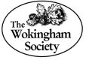

WOKINGHAM TOWN CENTRE’S CLOSED PUBS AND BREWERIES TRAIL Issue 2
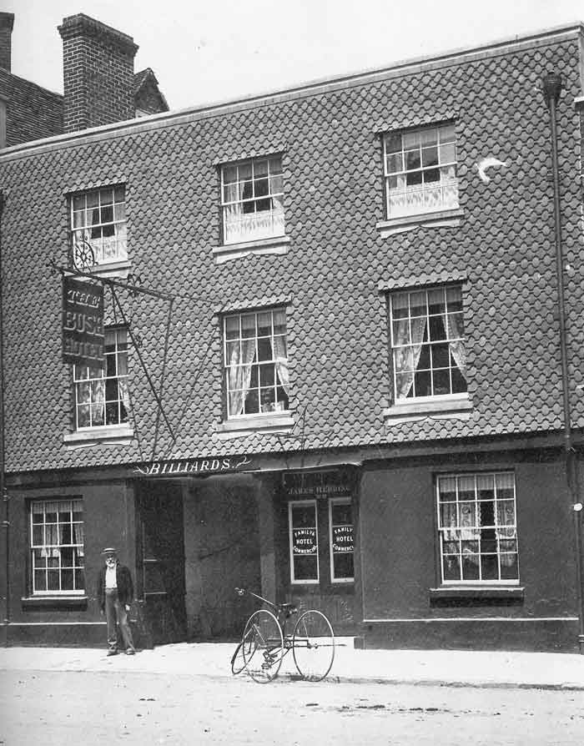
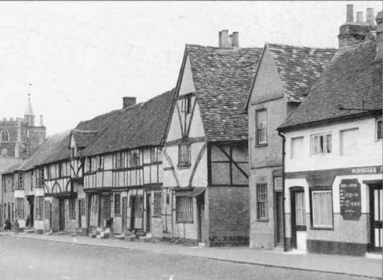
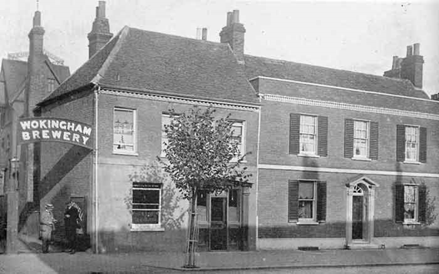
Photograph courtesy of Wokingham A Pictorial Photograph from Francis Frith's Wokingham History and Bracknell / Trevor Ottlewski
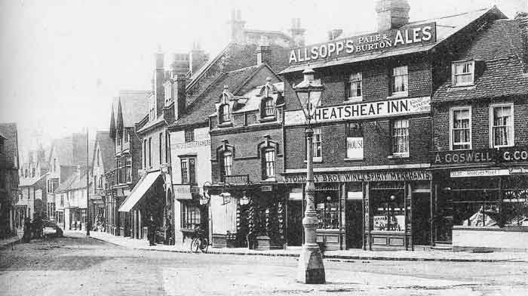
Photographs courtesy of Wokingham A Pictorial History by J. and R. Lea

Background

This leaflet provides a walking trail of pubs and breweries that have been closed in Wokingham and both quotes from and partially updates “Public houses, inns, beer houses and breweries of Wokingham” produced by Chris French, May 2020, which can be found here: - https://www.wildservice.org.uk/FHD/cpf-pubs.php

The leaflet is available from the Wokingham Town Council Information Centre and the Wokingham Library. The objective is to: -
Promote the history of Wokingham
Get people of all ages walking
Support our independent traders.

Additional information has been obtained and quotes from: https://museum.wokingham-tc.gov.uk/
https://www.wokinghamsociety.org.uk/ ,
Richard Gibbs’ “WOKINGHAM A POTTED HISTORY”, “THE INNS AND PUBLIC HOUSES OF WOKINGHAM” by Dennis Ayres and Judith Hunter, “Royal Ales” by Mike Brown, Brewer History Society and The WOKINGHAM BLUE PLAQUE TRAIL. I would also like to thank fellow Wokingham Society members, Guy Grannum for providing information from “The Genealogist”, Hazel Guile for her knowledge of Rose Street and Peter Must for proof reading this document. Unless otherwise stated, the photographs were taken by Kevin Lenton (who wrote this document) in 2025 and updated in 2026. Many thanks to Ian Burn for producing the map.

It is rumoured that Wokingham had more pubs per square mile than any other town in England. Richard Gibbs records that in 1580 had sixteen alehouses and two inns. Today there are a dozen pubs and a brewery, so a number have closed. The trail is focused on the town centre: The Terrace, Broad Street, Rose Street, Peach Street, Market Place and Denmark Street. The trail starts and ends with two pubs that are still open, The Queen’s Head and The Crispin, which are included in this guide for completeness. A map can be found on page 27.
Pubs & Breweries
The following pubs have closed but their exact locations are unknown:
Pub | Where |  | Known Dates
The Good Intent |  | Peach Street | Last mentioned 1854
The Six Bells |  | Cross Street | 1777 - 1793
The Red Cow |  | Market Place | Closed 1884
The British Workman |  | Market Place | Last mentioned 1881
The Spread Eagle |  | Down Street  (later renamed Denmark Street) | Last mentioned 1883
The Robin Hood |  | Down Street  (later renamed Denmark Street) | Closed 1854
The Sedan Chair |  | Down Street  (later renamed Denmark Street) | Last mentioned 1877

The Trail starts as stated at an open pub.

1. 23 The Terrace, Queens Head, at one time renamed the Welcome Home.

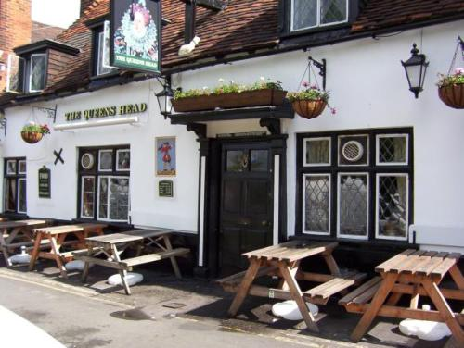

The Queens Head has been recorded as a public house since at least 1740. However, this Grade II Listed Building is considerably older and probably dates to the early 15th century. What makes this building unique is its timber frame, called a Cruck construction which in this case is basically of similar appearance to a capital “A”. The long uprights are formed with a curved trunk split along its centre and coupled together at the top. The strong shape provided the framework onto which the roof was supported and alongside which the walls were built. The use of the Cruck frame has been identified as having a regional bias and Wokingham lies to the very edge of that area. There are only seven buildings with this form of construction known in Berkshire. For a short time in the 1870s and 1880s the pub was called the Welcome Home, possibly due to the unpopularity of the queen for self-isolation after Prince Albert’s death. About 1883 the pub regained its old name.
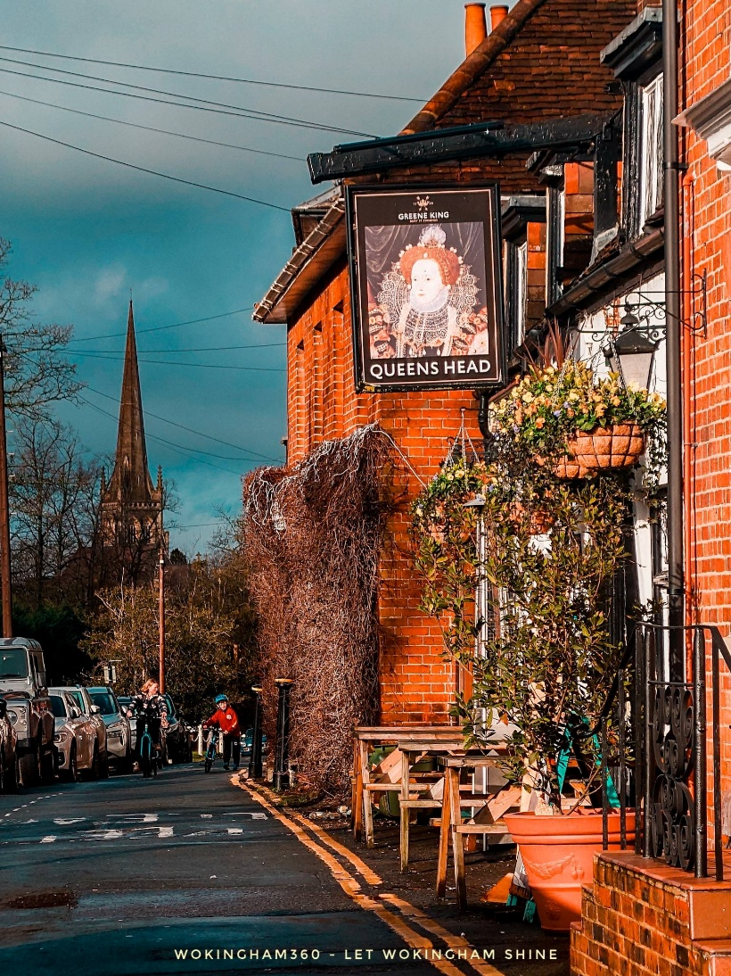
Photograph from Wokingham360

Turn right when leaving the pub and walk to: -
2. The Anchor, 37 The Terrace 1777 – 1910, now a private residence.
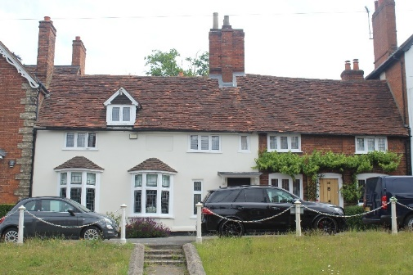
The Anchor Inn opened in 1777. In 1901 it was just six doors away from The Queens Head. The inn closed in 1910 and is now a private house. It is a Grade II Listed Building.

Walk back along the Terrace and into Broad Street, straight ahead of you, keep on your left hand side:-
3. The Shades, 15/17 Broad Street, last mentioned in 1901, now Northwood Estate Agents
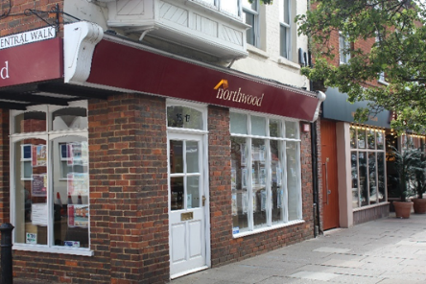
The Shades was a beerhouse, opened in 1851 after some local opposition from other breweries and the well-to-do residents of Broad Street. Rosalind Baker, a member of the brewing family, lived at the Shades. (Link to brewery, see 5).
A beerhouse was a type of public house created in the United Kingdom by the Beerhouse Act, 1830, legally defined as a place "where beer is sold to be consumed on the premises”
On the opposite side of the road is: -
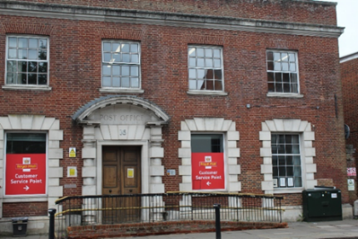
4. The Half Moon, 1700 – 1786, built on the site of what is now Royal Mail Delivery Office.
This was a licensed 17th century house. They, like several inns and alehouses organised local entertainments. In 1779 Jacob Pocock, the licensee, advertised a bull-baiting event to take place in the pub’s garden. The main location for bull-baiting was the Market Place where this took place once a year on St. Thomas’ Day (21st December).
George Staverton, a butcher who died in 1661, bequeathed a house, the rent from which was to provide two bulls to be tethered and to be baited by dogs. The meat and leather retrieved from the slaughter was later given to the poor people of the town. One bull’s tongue was given to the Alderman and the other to the Town Clerk. The practice was discontinued in 1821 by an Act against cruelty to animals.
Continue down on the left-hand side and look into Central Walk:-
5. Baker’s Brewery/The Wokingham Brewery
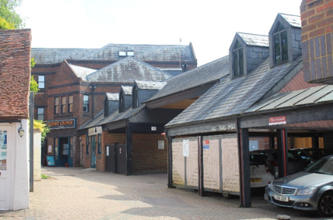
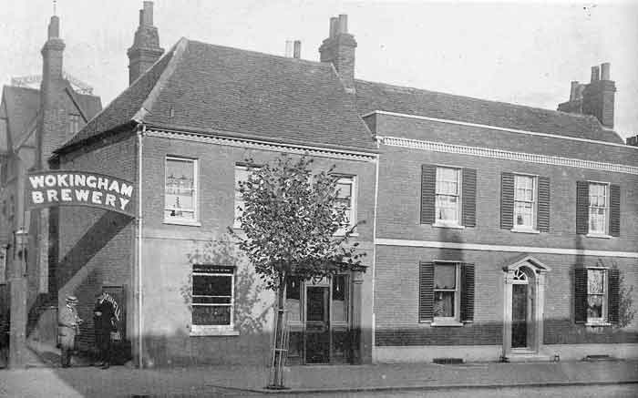
Was in Central Walk Earlier from: Wokingham – A Pictorial History / J&R Lea

Originally Baker's Brewery, it became known as The Wokingham Brewery late in the 19th century. By this time, it had acquired at least four public houses: The Crooked Billet, The Crown, The Hope and Anchor and The Railway Hotel.
It was sold to Breakspear’s in 1914, but they only wanted its tied properties and the Brewery itself closed early in the 1914-18 war.
Continue along Broad Street to:-
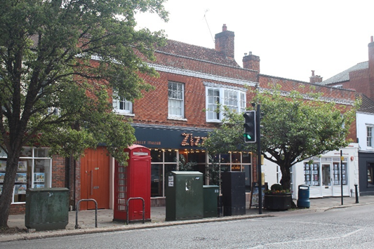
6. The Brewery Tap, 13 Broad Street, last mentioned in 1901, now Zizzi Restaurant
The Brewery Tap was next door to The Shades and probably interlinked: they were both used as a direct outlet for the Wokingham Brewery, behind these buildings.
At the end of Broad Street:-
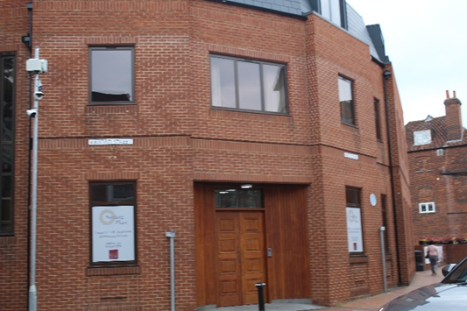
7. The George, 5 Broad Street, pre-1668, now Sterling Place.
This was an Inn with stables and a yard.
It was originally called The Georges.

Cross the road. Opposite is Clarks shoe shop:-

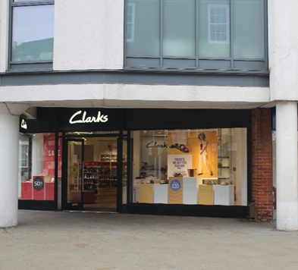
8. The Bell Inn, 42 Market Place, 1650 - 1750, now Clarks shoe shop.
This was in a part of Wokingham owned by the Dean of Salisbury Cathedral and an annual rent of 22 pence was paid to Salisbury until an act of Parliament stopped such payments.
Facing the entrance to the shoe shop, turn right into Rose Street and continue down the right-hand side.
Look down the street towards All Saints Church, it seems as if someone has built a house in the road. Rose Street is an example of an enclosed medieval street. It is probably the town’s oldest street. The street’s original name ‘le rothe’ meant ‘clearing in the woods’.
The Broad Street end was similarly narrow until the 1960s when it was widened for traffic access.
Continue along the right-hand side. Opposite is the following: -

9. The Poor Mans Friend, 12-14 Rose Street, first mentioned in1851, now Richard Worth Estate Agents.
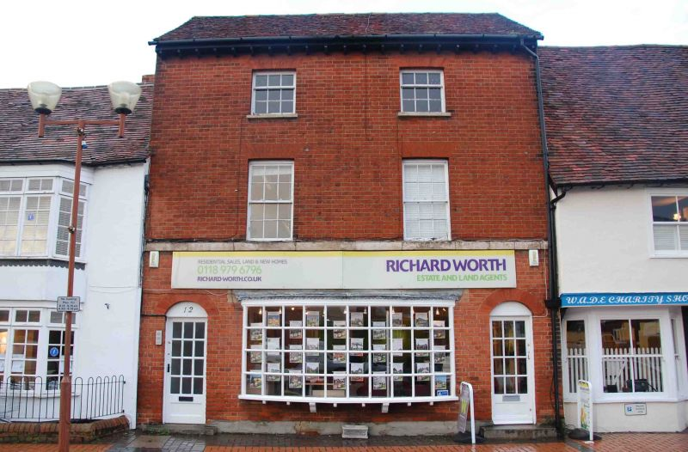

Nothing is known about this pub. This building, like many of the closed pubs for which the original building still exists, is Grade II Listed, which is defined as “a UK building of special architectural or historic interest”, thus deserving of special protection.
The photograph is from britishlistedbuildimgs.co.uk

Continue on right hand side:-
10. The Eagle, Rose Street, 1830 - 1863, built on the site to left of the original Wokingham Methodist Church, which was then extended onto the land vacated by the demolition of the Eagle.
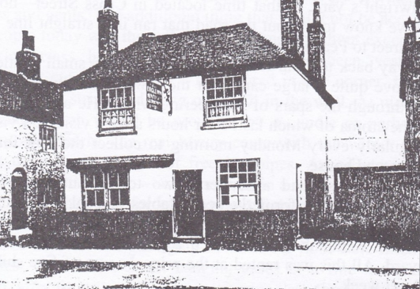
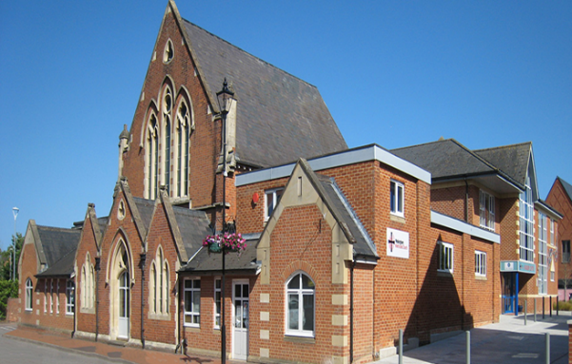
Now Earlier from Ken Goatley’s “Wokingham: The Town of My Life”

Now Earlier from Ken Goatley’s “Wokingham: The Town of My Life”
The Eagle was a retail outlet for the small Eagle brewery. The 1830 Beer Act gave a Brewery the opportunity to retail its own beer. In 1835 William Lewis had become the licensee and owner of the brewery. As often at this time the pub would pour beer straight from the cask into the glass.
In 1854 the pub was acquired by the Hewetts of White Waltham brewery. Hewetts had steadily bought pubs in Wokingham and owned eight, but when it got into financial trouble during the depression that followed the Boer war, it was purchased by the Morland Brewery.t was later renamed The Bear.
Continue and look to the right for: -

11. Bricklayers Arms, last mentioned in 1872, now the drive to the Wokingham Medical Centre.
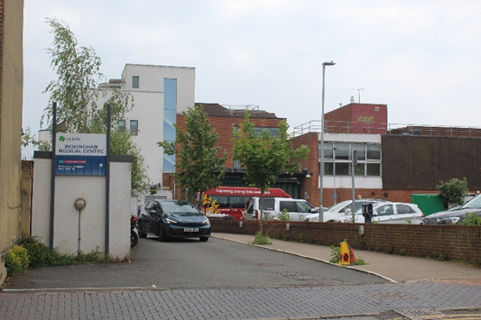
First documented in the victuallers register in 1770. A pigeon shooting competition was arranged by the pub in December 1771, although where it took place is unknown. It was bought by the Webb Brewery and then transferred to the William Haywood Brewery and was then sold in 1856, buyer not known.
12. The Cricketers, 29 Rose Street, closed 1901 and is now Inkfusion Tattoo Studio.
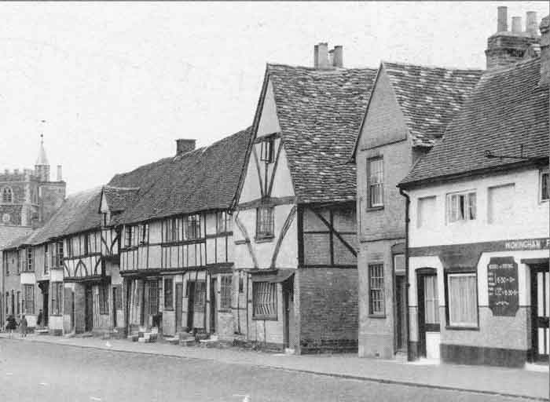
Current Location Earlier from: Francis Frith's Wokingham and Bracknell / Trevor Ottlewski
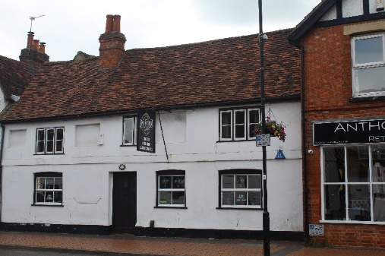

The 15th century building in the foreground of the photograph on the right has had a variety of uses, including (from the start of the 20th century) that of a public house called The Cricketers. In this photo it had very recently been converted into a fish and chip shop.
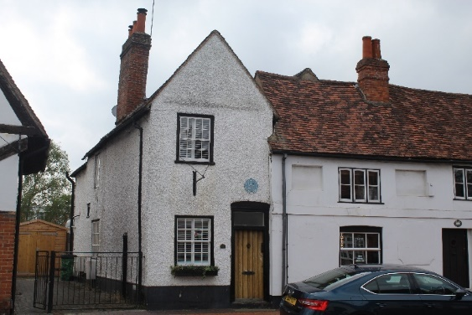
13. Queen’s Arms, 31 Rose Street, existed in 1901, now a private property
This building was purchased by William Bremner, the minister at Wokingham and the Master at Lucas Hospital, from a bequest in the will of Martha Palmer in 1795 and was fitted out as “The Maiden School”.
In 1842 the school was amalgamated with the National Infants School at 21 Rose Street.
By 1875 the National Schools were reformed as the Palmer Schools and relocated to new buildings. The trustees then rented out 31 Rose Street. The first tenant was James Seaward, a chimney sweep, with a wife and growing family, who lived there for 44 years.
It is believed that James was the inspiration for Charles Kingsley’s “Tom" in the “Water Babies”.
14. The Metropolitan, 58 Rose Street, now the Grasshopper Wine & Cocktail Bar.
This photograph taken about 1920 shows the landlord and some of his customers outside the Metropolitan beer shop in Rose Street.
The owner is wearing the bowler hat and shirtsleeves. The building is a 15th century hall-house, modified over the centuries to meet the needs of its owners.
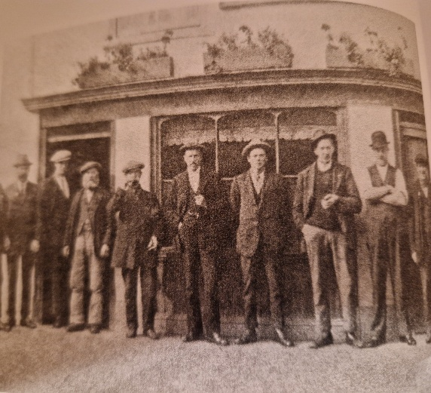
The photograph was taken from Richard Gibbs’ “WOKINGHAM A POTTED HISTORY”
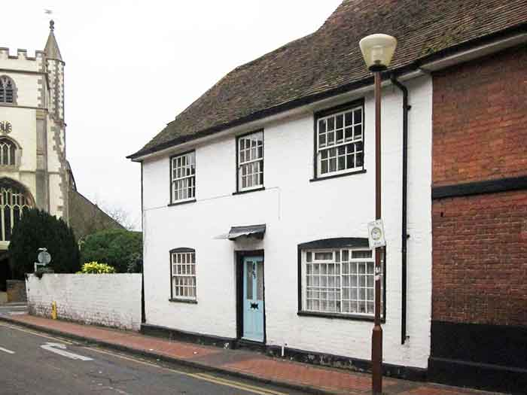
15. The White Hart – 65 Rose Street, existed in 1901 and is now a residential property.
In 1901 this was one of 7 public houses in the short length of Rose Street. It was the home of the Rose family.
In the 1970s it was owned by Phil Parkes, a former West Ham and England goalkeeper

Turn right and go past the Ship Inn and go down Peach Street keeping to the right:-
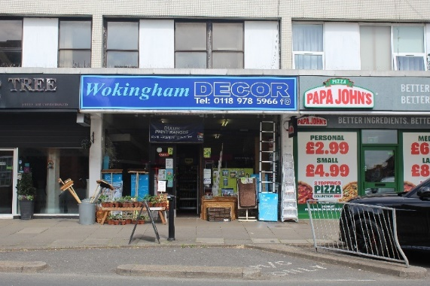
16. The Star, 56 Peach Street, c 1880 – 1909, now Wokingham DÉCOR.
The Star Inn was directly opposite what is now known as Easthampstead Road, which was until 1886 Star Lane (hence the Star Lane railway crossing).
The inn closed in 1909 and has since been demolished and its site taken over by this parade of new shops.
Continue down Peach Street and opposite will be: -
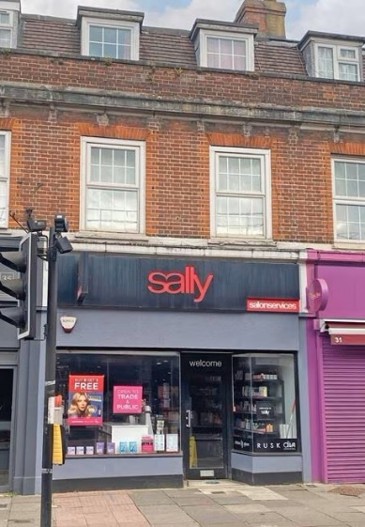
17. Welcome Inn, 33 Peach Street, 1850 – early 1960’s, now Sally Salon Services.
There was a survey taken in 1907 of the smaller public houses by the county licensing committee, of which this was one. The report identified those pubs that had dining rooms and this pub was said to be a “Good Catering House”. Continue to see opposite: -

Continue to see opposite:-
18. The Crown, 29 Peach Street, existed in 1910, now Harringtons hair dressers.
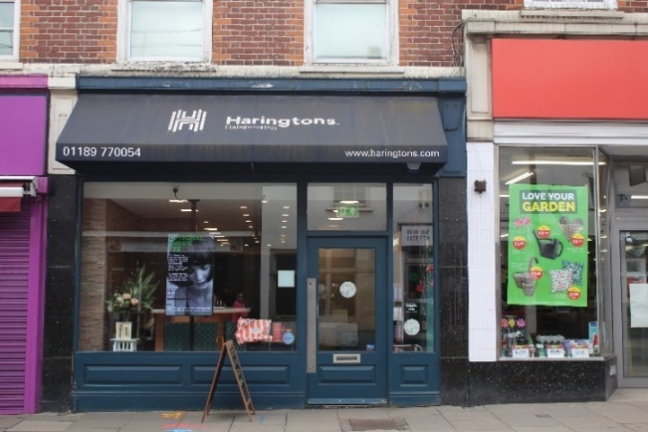
This pub was very small with a minute bar, and was set back. It was mentioned in the Tithe Apportionments in 1835. A report in 1907 states that the pub could only be reached through a yard, which led to a saw mill and other premises. A that time with a profit of less than a £1 a week, the pub struggled.
This parade of shops, including the ex-Woolworths store to the right, was redeveloped in the 1930s.
Continue to: -
19. The Nags Head, 30 Peach Street, pre-1770, then The New Rose, 1772 – 1788, now Wokingham Forces Support.
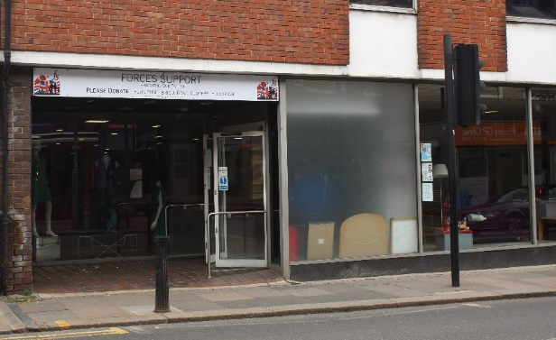
The opening of the New Rose was mentioned in the Berkshire Chronicle in 1772. It was a 15th century timber framed building opened by a John Chaplin. It was closed by his widow in 1788 when she had the opportunity to lease the original Rose. The site was later shops.
Continue along Peach Street and opposite is: -
20. Eagle Brewery, 7 Peach Street, 1820 to 1863, now Happy Snaps.
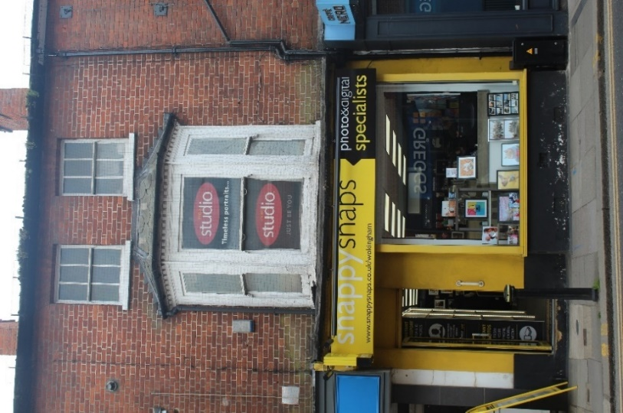
The small Eagle Brewery at 7 Peach Street opened in about 1820. The 1830 Beer Act allowed it to sell its own beer, so it obtained an off-licence. In 1854 the brewery was bought by Hewett's Brewery of Waltham St. Lawrence but appears to have closed by 1863, although it continued as a beer and spirits retailer until 1982 when the off-licence was owned by Breakspear’s.
The Beer Act liberalised the regulations governing the brewing and sale of beer. It was passed in response to the problem of drunkenness in England among the working
classes caused by cheap gin. The Act allowed virtually anyone able to afford it to obtain a licence to brew and serve beer but not wines and spirits in their home. The Act was repealed in 1993.
At the end of Peach Street turn right into the Market Place, with the town hall opposite you.
To the right is: -

21. The original Rose – 35-36 Market Place 1629 – 1772 and 1788 – 1844, now Superdrug.
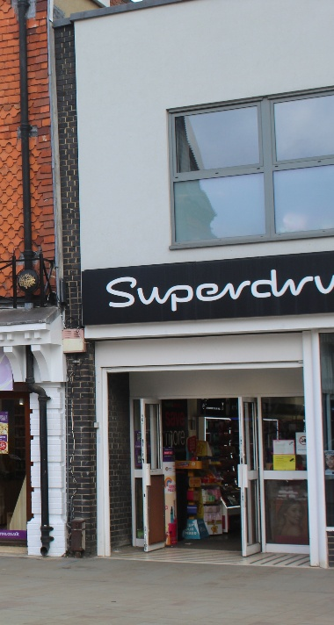
This was a timber framed building part of which was built in 15th century. John Chaplin bought a 20-year lease in 1752 and became postmaster for Wokingham in 1755, for a fee of £ 6 a year.
The pub was used for local business and in particular for house auctions and sales of timber.
The Rose was also used by the Berkshire deputy lieutenants for meetings.
When it closed in 1844, it became a drapers and outfitters shop and later was demolished to make way for shops.

Next door is: -

22. The Bush Hotel - 37 Market Place, 1701 – 1986.
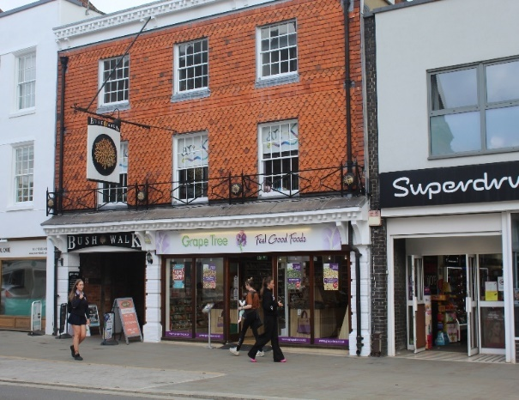
Now Bush Walk Earlier, from: Wokingham – A Pictorial History / J&R Lea
The timber-framed 15th and 16th century buildings that make up much of present-day Bush Walk were previously part of the Bush Hotel. The earliest reference to a licenced property was in 1700 and it was run by a Mrs Simpson and owned by a local brewer John Hawes, although there is some evidence that an earlier Busshe existed in 1562. After being a stagecoach inn for 100 years, by 1901 it had become a hotel.
The Bush Hotel closed in 1986 and has now transmuted into the Bush Walk shopping arcade. The pub-like sign is clear to see, although the design is very modern.
Cross over the road turning left with the Town Hall on your right-hand side and walk towards W H Smith/Post Office:-

23. King’s Head, 26-28 Market Place c1700 – 1852, now T G Jones/Post Office.
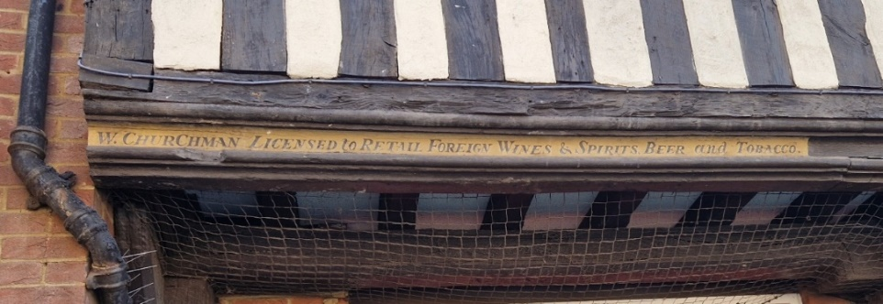
This was where the Post Office is now, and if you look up above the entrance you will see the following: -

William Churchman was the last licensee of this pub. Previously; Joe Rushton had been the licensee for 35 years. A stagecoach operated from The King’s Head and, supposedly, King George II visited Wokingham in the eighteenth century to see the baiting of the bull in the Market Place and stayed at this pub.
Continue along the Market Place to: -

24. The Wine Vaults, 22 Market Place, 1875 – 1974, now Feather & Sole, ladies’ clothes and accessories.
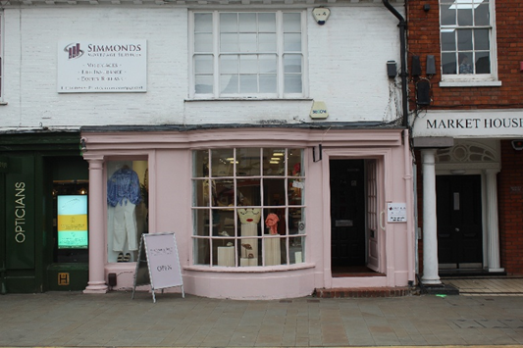
This wine and spirit shop had once sold wine to the church and it obtained a full licence to become a public house in 1877, and was named Paul Holton’s Wine and Spirit Business. It closed in 1974 soon after it had been acquired by Morland’s Brewery
Cross the road and walk back up the Market Place with the Town Hall on your right to: -
25. The Hart 1608 – 1640, 3 – 4 Market Place, now Cancer Research UK.
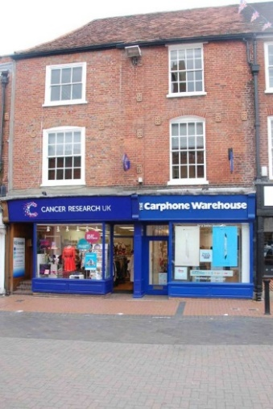
Some Inn Keepers had to pay a yearly rent. It is documented that Mr. Lypperscome paid 9 shillings and 4 pence in 1629 to the Lord of the Manor of Sonning.

Turn back and walk down the Market Place to: -

26. The Wheatsheaf, 14 & 15 Market Place,1876 – 1926, now Ladbrokes.
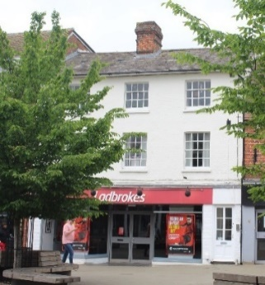
Now Then from: Wokingham – A Pictorial History / J&R Lea

The picture on the right is a view from Market Place looking down Denmark Street. The Wheatsheaf Inn is an early 19th century building. As can be seen it was not tied to a brewery, selling both Allsopps Ales and Stollery Brothers wines and spirits.
In 1900 a tramp pleaded guilty to breaking a glass door at the pub and was committed to Reading Gaol for seven days in default of paying a fine and costs.
Continue down Denmark Street and turn right into the Plaza:-
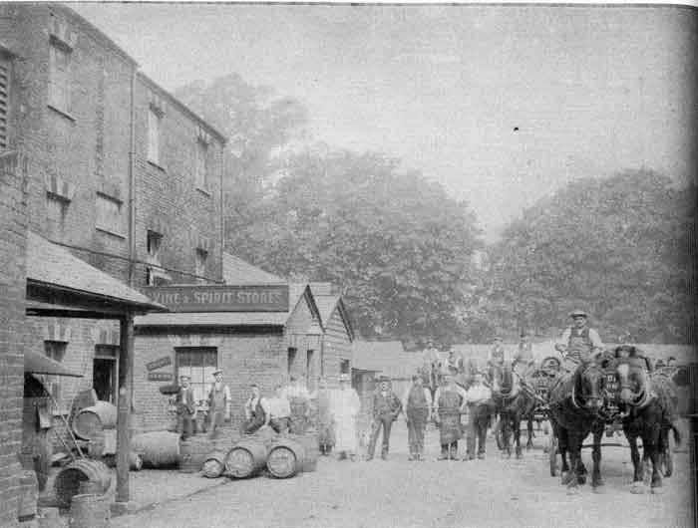
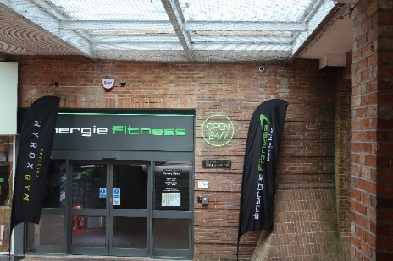
27. The Wellington/Headington Brewery, on land behind 4 Plaza, 1856 – 1928, now Energie Fitness Gym. Now Energie Fitness Gym Earlier from Britain in Old Photographs - P Wokingham/ Bob Wyatt

In 1856, when the Haywards brewery empire was being split up, Robert Trickey Dunning, a plumber and glazier living on The Terrace, bought The Chair in Denmark Street. Robert also bought land behind the Chair, upon which he built the Wellington Brewery.
The brewery flourished and by 1877 was selling nearly 2,500 barrels a year.

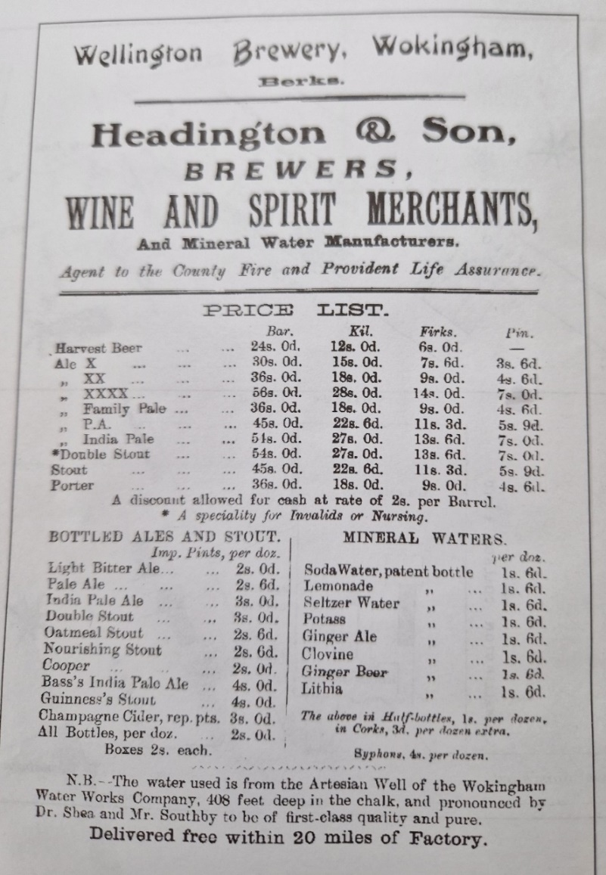

Thomas Dunning decided to retire from the brewing business in 1877, when only 41 years old, and the brewery was put up for sale at an auction and the whole estate was bought by Messrs. Headington and Webster for £ 11,400. The estate was taken over first by Frank Headington and his cousin Richard Webster, in partnership, and then by Frank's son John, who was the owner in 1901.
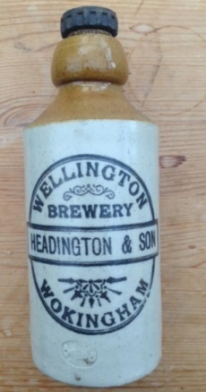
The brewery flourished until 1920, when it was sold to Messrs Ashbys, the owners of the Staines Brewery.
As usual in these cases, the new owners wanted the tied pubs as outlets for their own beer, rather than the brewery for its beer.
The last excise return for the brewery was in 1928.
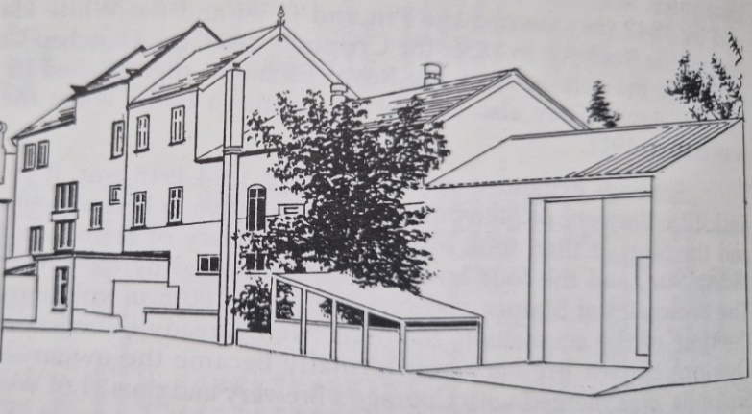
Some of the buildings were used to supply wines and spirits. After the 1939-45 war, the brewery buildings were used as the local Civil Defence Headquarters. In 1970 the buildings were then used to house the Berkshire Crafts Centre Association.

Drawing by Doug Thompson in 1975.
Return to Denmark Street and continue down right-hand side. Opposite is: -
28. The Royal Exchange, 20 Denmark Street, 1853 – 1962, now Resource House, Berkshire Healthcare.
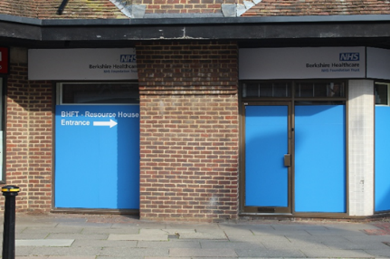
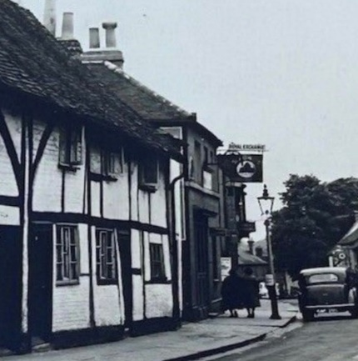
Now 1950s

Picture source: Hania Franek
The pub had been owned by Simonds Brewery; their logo can be seen in the pub sign and it was then sold to Courage’s Brewery. The Royal Exchange was closed in 1962 due to economic reasons and the site was left empty for many years.
Continue to: -
29. Wellington Arms, 23 Denmark Street,1750 -1937, now Hair Poetry.
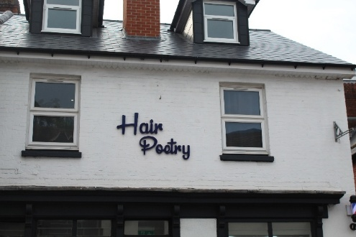 | The Wellington Arms stood on a site that had previously been the Sun, or Old Jenkin’s House. It then became the Two Chairmen and known as the Chair.  Robert Trickey Dunning bought  The Chair in Denmark Street. He also  bought land behind the Chair, upon which he built the Wellington Brewery.
Continue down Denmark Street and complete the trail at The Crispin:-
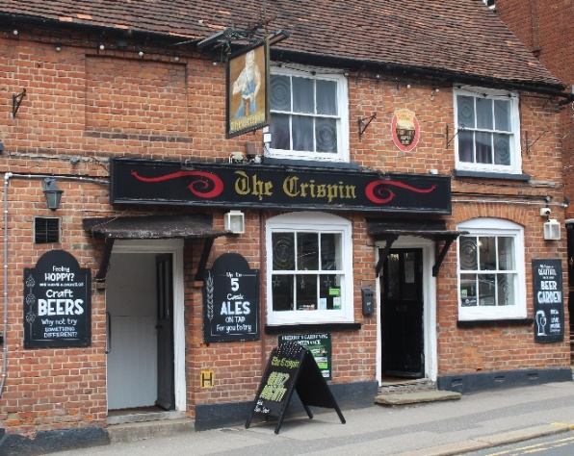
30. The Crispin, 45 Denmark Steet, 1840 to now.
The Crispin is one of the oldest buildings in Wokingham. It was built in the 15th century as a hall-house. This means it had a large central hall – the main room of the building – open to the roof, with a fire in the centre of the room. It was obviously the home of a prosperous man. In later times it was modernised, and an upper floor built across the full breadth of the house. Sometime later it was divided into three cottages.
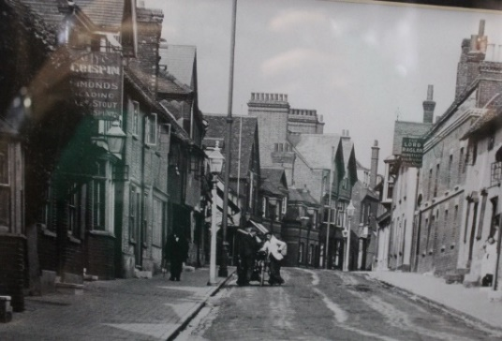
1935
By 1854, the owner of the central cottage (James Green) had become sufficiently prosperous as a 'brewer and beer seller', to buy out the other two owners and obtain a full licence. James Green had been a shoemaker. It is believed that this is when the pub was named The Crispin, as St. Crispin is the patron saint of shoemakers.

Closed pubs and breweries’ locations.
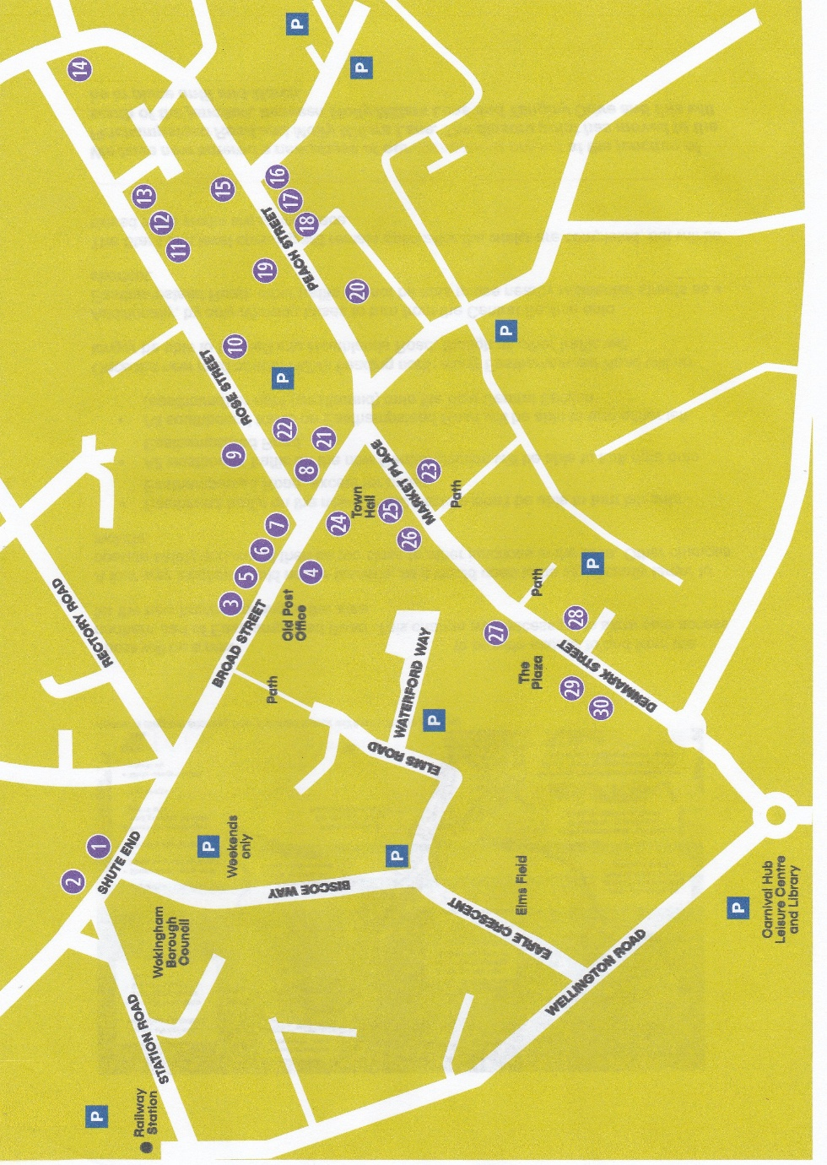
This booklet has been produced and paid for by the Wokingham Society, which is a Civic Society established in the 1960s to combat the threat to the town's buildings and facilities from widespread and often thoughtless redevelopment. Although it has not always been possible to prevent the loss of individual landmarks, the Society's voice has been significant in helping to preserve many local historical features and to ensure that development has been sensitive to the town's heritage.
The Society's aims are clearly set out in the constitution which is available on the website www.wokinghamsociety.org.uk but its main purposes may be summarised as:
• Encouraging the conservation of the character and traditions of Wokingham as an historic market town
• Promoting study of the history of Wokingham and interest in our heritage, for which this document supports
• Welcoming new development and business which enhance and invigorate the town while constructively opposing measures that do not
• Proposing improvements to the town's environment and amenities. To contact The Wokingham Society please email the Chairman or the Secretary, whose email addresses are available from the website.
